**2017 Fall Retreat Registration**

(Fill out one form per student)

Name: ___________________________ Grade: _________

If invited by a friend, who invited you? ________________

Any allergies? ____________________________________

**Emergency Contact Info for September 23-24:**

Name: ______________________ Relation: ____________

Home #:__________________ Cell #:_________________

**When will you be joining us:**

* 9:30 am on Saturday, September 23 at Shoreline to carpool to Beulah Beach
* Meeting you there after sporting events
  + Estimated arrival time: __________________

**___ Yes, I have filled out and turned in the 2017-2018 Annual Activity Form**

**___ Yes, I have included the $50 registration cost** (please make checks payable to Shoreline Church)

___ Yes, I give permission for my child’s picture to be taken during the retreat and used in church newsletters, displays, webpages, social media, etc.

___ Yes, I waive any claim against Shoreline Church for this retreat

Parent’s Signature: ________________________________

**2017 Fall Retreat Registration**

(Fill out one form per student)

Name: ___________________________ Grade: _________

If invited by a friend, who invited you? ________________

Any allergies? ____________________________________

**Emergency Contact Info for September 23-24:**

Name: ______________________ Relation: ____________

Home #:__________________ Cell #:_________________

**When will you be joining us:**

* 9:30 am on Saturday, September 23 at Shoreline to carpool to Beulah Beach
* Meeting you there after sporting events
  + Estimated arrival time: __________________

**___ Yes, I have filled out and turned in the 2017-2018 Annual Activity Form**

**___ Yes, I have included the $50 registration cost** (please make checks payable to Shoreline Church)

___ Yes, I give permission for my child’s picture to be taken during the retreat and used in church newsletters, displays, webpages, social media, etc.

___ Yes, I waive any claim against Shoreline Church for this retreat

Parent’s Signature: ________________________________

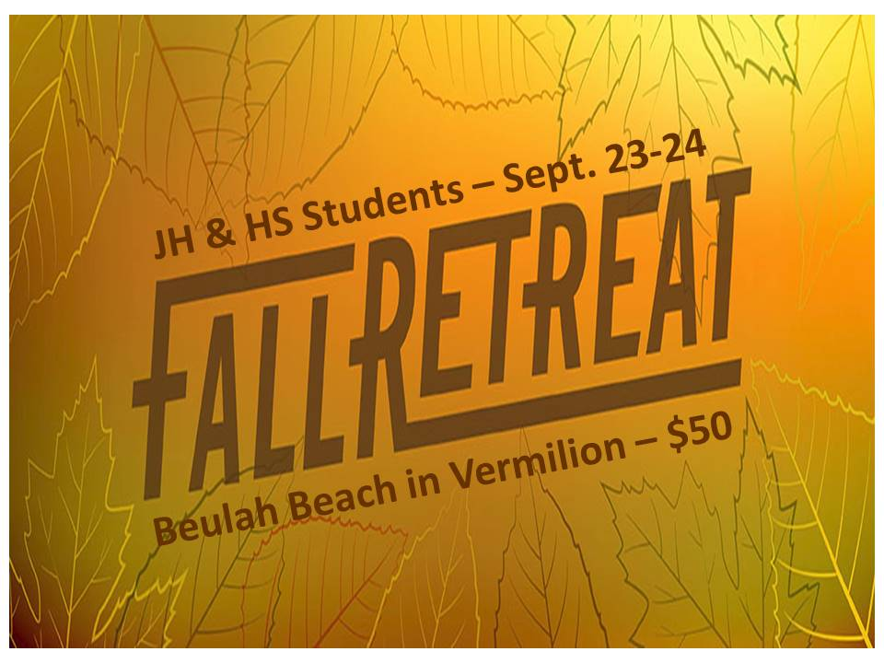

**Will you join us for the 2017 Fall Retreat?**

All JH and HS students (6-12th grade) are invited to join us on September 23-24 for the Fall Retreat! To kick off our theme of Knowing Him, we will be exploring the question “Who do you say I am?”

We will plan to leave Shoreline at 9:30 am on Saturday, and return around 5:00 pm on Sunday. If you have a sporting event that day, you have the option to meet us at Beulah Beach afterwards. Check out the camp website at <https://www.beulahbeach.org/guestgroups>.

**Registration, money and**

**Annual Activity Form**

**must be turned in by**

**Friday, September 15.**

**Once registered, more**

**details will be sent to you.**

**Will you join us for the 2017 Fall Retreat?**

All JH and HS students (6-12th grade) are invited to join us on September 23-24 for the Fall Retreat! To kick off our theme of Knowing Him, we will be exploring the question “Who do you say I am?”

We will plan to leave Shoreline at 9:30 am on Saturday, and return around 5:00 pm on Sunday. If you have a sporting event that day, you have the option to meet us at Beulah Beach afterwards. Check out the camp website at <https://www.beulahbeach.org/guestgroups>.

**Registration, money and**

**Annual Activity Form**

**must be turned in by**

**Friday, September 15.**

**Once registered, more**

**details will be sent to you.**