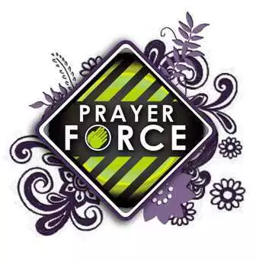 ***CALLING OUT TO GOD FOR THE ONGOING MINISTRIES OF SHORELINE CHURCH!***

**November Part 1/ 2018**

**CHILDREN’S MINISTRY:** Tracy Hartlage

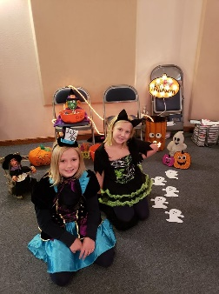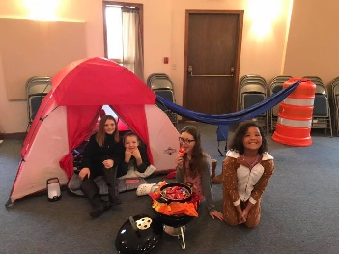**Praise Report:** Despite the weather, we had a great time at the (indoor) Trunk and Treat! * I will put a couple pictures in.

**Prayer Requests:**

1. As of today, we have 18 days to collect and pack show boxes for Operation Christmas Child! All packed boxes need to be at the church on November 18th! Pray that God would use this project as a tool for families to pursue God's mission, TOGETHER! Pray as people pack boxes that God would use those boxes to share His love to families all around the world.

**YOUTH MINISTRY:** Callie Willoughby

**Praise Report:** We have finished our Life in 6 Words Curriculum, and at least one student has made a decision for Christ as a result!

**Prayer Requests:**

1. The Harvest Fest is on Saturday, November 10. Pray that our students would be bold in inviting their friends and be intentional in conversation with them throughout the event. This is always a fun night to just hangout.
2. Pray that God would help us develop a deeper gratitude this Thanksgiving season.
3. Praise and thank God for the students, parents and coaches who are a valuable part of our ministry! It is a blessing to be able to learn and grow alongside each of you.

**TOTAL CHURCH MINISTRY:** Bill Blue

A close up of text on a white background

Description generated with high confidence

**Praise Report:** God brought us at least one family due to our involvement in Apple Fest! * See Callie’s report: 1 New Believer in Christ!!

**Prayer Requests:**

1. Pray for wisdom as your church’s leadership prepares next year’s budget!
2. Pray that our staff stays healthy with all the sickness in our area! It’s hard to think clearly when sick.
3. Pray that God would use our Special Service on Nov. 18th with Joel Penton as a tool to help Shoreliners to reach out to their peers! That God would bring up spiritual discussions because of this event!



**#OB4HG!**