May 31st 2020
We will only reopen when we have a plan that honor’s God, demonstrates God’s love for others, and when we can operate that plan in a way that represents Jesus well!

Lord, in the midst of the frustration and anxiety in our world help us to represent You well by…

- Being responsible citizens who follow Jesus!

(Titus 3:1-2 & Romans 13:1-2)
- Embracing self-sacrifice!

(Romans 14:1-3 & 13; 1 Corinthians 8:9)

- Being humble and admitting that you do not have all the answers.

(Philippians 2:3)

- Being an example of attractive unity in a divided world!

* Today’s message was adapted from an article written by Brett McCracken.
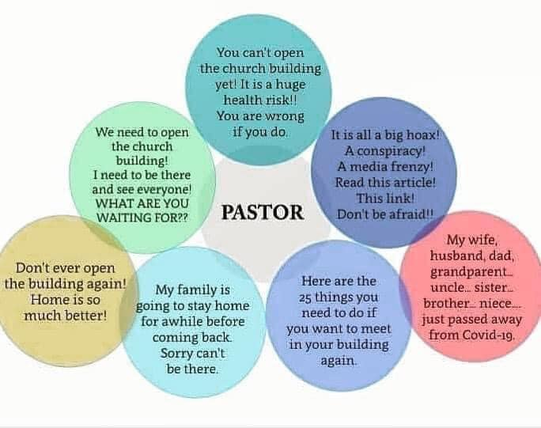
- What are your feelings about reopening our Sunday Service?
- How do you think personality, age, and health concerns could affect one’s view on reopening?
- Can someone have different views, and both still be right about reopening?
- Take a moment to read over each point and the Scriptures listed with each.
- What stands out to you in your Scripture reading?
- Which of the 4 do you think is easiest for you and which is hardest? Why?
- What would it look like in your neighborhood if Shoreline became the talk of our area, because of how Shoreline reopens? Because people see our unity and passion!

What is your next step?
- Volunteer.
- Pray.
- Enjoy the ride of asking the Holy Spirit to build one of the characteristics identified today, into your life.
- Do the work of reestablishing relationships with people that you have not seen for a while.
- Recommit to partnering together to love God, love people, and make disciples!

