Mark your calendars…
Upcoming dates for Category 6ix

MESSY GAMES NITE – WED, AUGUST 3 (JH) & SUN, AUGUST 7 (HS)
Come prepared to get MESSY! Shaving cream, cool whip, slime, color powder, and rotten foods are not all promised, but are possibilities. Wear clothes that you do not care about getting messy! Also, bring a towel to dry off, after we hose you down at the end, of course! Invite your friends! 6:30-8:00 pm at Shoreline. We will still have our bonfire and s’more stories at the end!
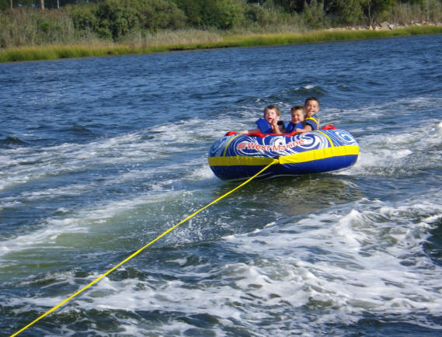
BEACH/BOAT DAY – SAT, AUGUST 13 (JH & HS)
Join us for one last fun day before school starts! We’ll spend some time soaking
up the sun on Lake Erie. Jake Jacobs and Dave Sherman have graciously offered
to take students out on their boats, which could involve tubing! When it is not
your turn on the boat, we will hang out at the Port Clinton Beach (on Perry St).
1:00-5:00 pm (Note the time change from the original summer schedule).
If you need a ride to the beach, let Callie know by Sunday, August 7.
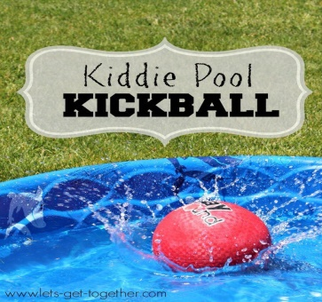
FALL KICK OFF – SUN, AUGUST 21 (HS) & WED, AUGUST 24 (JH)
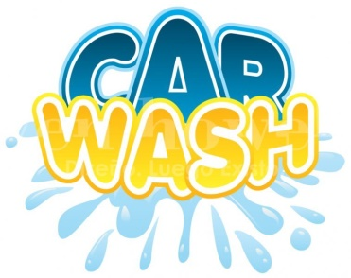
Back by popular demand, we will be kicking off the Fall with the second annual Kiddie Pool Kickball! Make sure to wear clothes that can get wet, and bring a towel! Invite your friends to join you for fun, food, and fellowship! I look forward to kicking off Category 6ix for the Fall, & sharing about the theme for the upcoming year!
HS – Sun, August 21 – 6:30-8:00 pm at Shoreline.
JH – Wed, August 24 – 6:30-8:00 pm at Shoreline.

FAMILY IMPACT CENTER GARAGE SALE AND CAR WASH – SAT, AUGUST 27
As a result of a student-driven idea, we are coming together as a church to raise some
funds for the Family Impact Center. The youth are responsible for the car wash portion
of this event! 10 AM-4 PM, Saturday, August 27. Sign up to work a shift!

BACK TO SCHOOL BASH – SUN, AUGUST 28
Celebrate the new school year with the Shoreline Family! This event will be hosted at the Carroll Township Complex, Shelter House #2, on SR 19.
4:00-8:00 pm (hangout, games, dinner, and baptism service). Bring lawn chair, and dessert or side dish to share. If you are interested in being baptized, I can connect you with Pastor Bill!
POINTFEST @ CEDARPOINT – SAT, SEPTEMBER 17
Join us for a day filled with riding roller coasters and worshipping our God at an awesome concert (For King and Country, Toby Mac, Chris Tomlin, and Hollyn). Early bird tickets on sale until August 19 – only $52. The church will cover half of each ticket price for the youth, which makes it only $26. Turn in money to the black box by Wed. Aug 17th. Additional tickets for family members can be bought at full price.
Please contact Callie with any questions you may have: 563-249-1454 or callie@theshorelinechurch.net.

